Annual Report 2024-2025

St. Pious X PG (MBA) College for Women
An Autonomous College
Reaccredited with A+ Grade by NAAC Snehapuri Colony, Nacharam, Hyderabad, Telangana
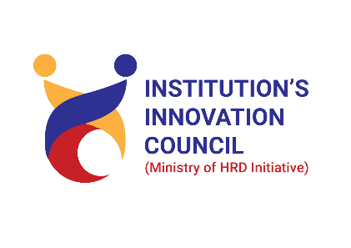

- About IIC Institute

Our Vision:
To empower Women through start up ecosystem and function effectively as competent, innovative entrepreneurs.

Our Mission:
  - To promote innovative thinking.
  - To develop entrepreneurship skills.
  - To organize idea contests to showcase the innovative ideas.
  - To support innovations targeting societal priorities.
  - Follow guidelines recommended by MHRD’s IIC initiative.

Achievements/Organized/Participated
IIC Calender Activities
IIC 1.0 | All the activities as mandated by MIC
IIC2.0 | All the activities as mandated by MIC
IIC3.0 | In Q1& Q2, 3 activities were suggested by MIC, Our IIC has accomplished 8 activities, In Q3 & Q4, we have done 6 activities as suggested by MIC
IIC4.0 | 14 Calander activities as mandated by MIC
IIC5.0 | 15 Calander activities as mandate by MIC
IIC6.0 | All the activities as mandate by MIC
MIC activities
IIC 1.0 | Active participation in all the activities
IIC2.0 | Active participation in all the activities
IIC3.0 | Active participation in all the activities
IIC4.0 | Active participation in all the activities
IIC5.0 | Active participation in all the activities
IIC6.0 | Active participation in all the activities
IIC7.0 | Active participation in all the activities
Self driven Activities
IIC 1.0 | All the activities as suggested by MIC
IIC2.0 | All the activities as suggested by MIC
IIC3.0 | All the activities as suggested by MIC
IIC4.0 | 10 self-driven activities as suggested by MIC
IIC5.0 | 17 self -driven activities as suggested by MIC
IIC6.0
Participation in Hackathon
IIC 1.0 | Total no. of Ideas submitted to SIH19: 20 One team reached and won in Grand finale
IIC2.0 | Total no. of Ideas submitted to IIC were 13 out of which we screened 7 through Internal Hackathon for SIH20.
IIC3.0 | Total no. of teams submitting the ideas in Toycathon were13 from which three teams reached grand finale. One team reached the power round . For Toycathon we also served in the capacity of Nodal center too. The SPOC for Toycathon 2021 from our IIC was Dr. R. Komala, Convenor, IIC, St. Pious X Degree & P.G. College for Women
IIC4.0 | Total no of 8 teams of students participated in Internal hackathon.
IIC5.0 (Cyber hackathon “KAVACH – 2023” | Total 6 teams of students participated and submitted their ideas in KAVACH -2023 portal. Dr. Anjana Shukla, President IIC, St. Pious X Degree & P.G. College for Women was the SPOC for Cyber hackathon.
IIC5.0 Internal hackathon SIH- 23 | Total 23 teams of students participated and submitted their ideas in SIH-23 portal. Dr. Sushama, member IIC was the SPOC for Hackathon 2023.
IIC6.0 Internal hackathon SIH-24 | Total 15 teams of students participated and submitting their ideas in SIH-24 portal. Mrs. Harshanya Papulla, NISP Coordinator was the SPOC for Hackathon 2024.
IIC6.0 Internal hackathon SIH-25 | Total 24 teams of students participated and submitting their ideas in SIH-25 portal. Mrs. Anitha, NISP Coordinator was the SPOC for Hackathon 2025.
Innovation Ambassadors
IIC 1.0 | Nil
IIC2.0 | 4
IIC3.0 | 11
IIC4.0 | 11
IIC5.0 | 11
IIC6.O | 11+7
IIC7.0 | 11+7`
Star rating
IIC 1.0 | 4 stars
IIC2.0 | 4.5 stars
IIC3.0 | 3.5 stars
IIC4.0 | 3 stars
IIC5.0 | 2.5 stars
IIC6.O | 3 stars
IIC 7.0 | Anticipating 5 stars

  - t

IIC certificates of ranking

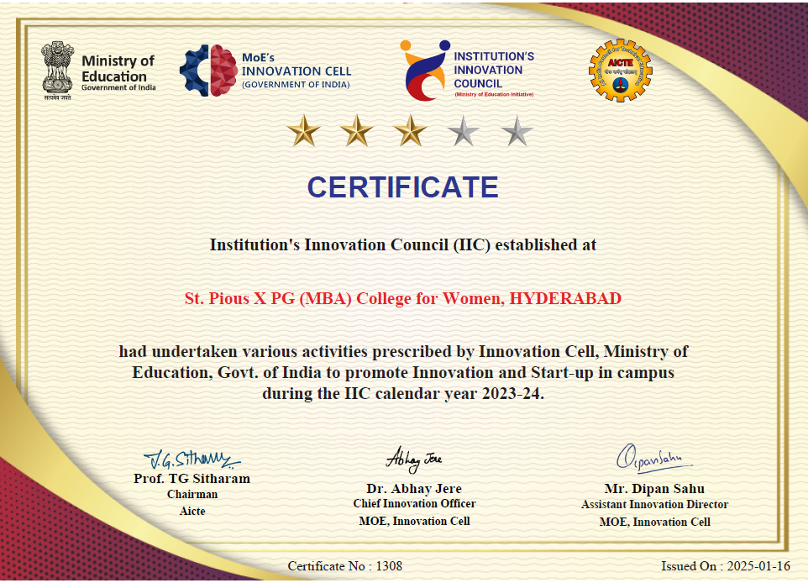
Diversified representation in the IIC established at the institute from industry, Interdisciplinary & Departments/ Units etc.

- Brief mention of key functionaries at the IIC Institute

President

Dr. Anjana Shukla, Assistant Professor, St. Pious X Degree & P.G. College for Women.
Leading the IIC Council custodian of IIC portal login and data reports uploaded therein. Conducting meetings, set meeting agenda and will monitor the deliverable. main point of contact with MHRD Innovation Cell Responding to all communication from IIC National Coordination team (MHRD Innovation Cell) Ensuring decent performance of IIC. Coordinating with MHRD innovation cell ensure Institution’s participation in IIC calendar activity and take lead in the institution driven activities (own initiatives). Ensure the effective implementation of IIC activities with the help of Convenor.

Vice President
Mrs. Anika Sunkara, Assistant Professor,
Department of Business Management, St. Pious X MBA College for Women
To build and strengthen the inhouse mentor pool and human resource capacity to drive campus Innovation & Entrepreneurship activities. Identifying, handholding and guiding potential/early-stage entrepreneurs, student innovators at the Institute on regular basis. To Develop a critical mass of motivated students & faculties with creative potential, and Entrepreneurial orientation & skill set. Commercialization of innovations through technology transfer, technology licensing and Startups, etc. To build infrastructure support and facilities to promote innovation and enabling environment of easy access to resources within and outside the institute. To strengthen the intra and interinstitutional partnership and collaboration with ecosystem at different level and cocreation of new program interventions

Convenor

Dr. Ch. Snehalatha, Assistant Professor,
Department of Chemistry, St. Pious X Degree & PG College for Women
The Convenor will work in close coordination with IIC president and will provide help wherever required for smooth conduct of activities.
She will ensure the participation in the meeting and will prepare the meeting agenda at least 10 days prior to meeting with the inputs from all valuable council members and President.
Maintain documentation of the proceedings like meeting photos, Minutes of Meetings, Meeting Video has to uploaded to Institution YouTube Channel and the link has to be shared with competent authorities and any other proof. She will ensure that the internal examination dates would not interfere with the IIC activities and coordinate with all departments to ensure the same.
She will collect the inputs from all the members of the council at regular interval, especially external members for better planning of IIC activities and effective delivery of the same.

Coordinators
Ensure the Institution’s Innovation Council’s logo and the words “in association with Institution’s Innovation Council, Ministry of Education (MoE), Govt. of India”, is included in the brochure compulsorily for all the academic activities of their respective departments like webinars, seminars and workshops related to Industry Interaction, Startup, Entrepreneurship, Research and Innovation / Intellectual Property Rights (IPRs). Establish Innovation Clubs for students with facilities and equipment needed for Innovation and Entrepreneurship (I & E) activities in their respective departments.
Developing an Innovative and Entrepreneurial mindset through a series of activities like workshops, awareness, market outreach events, orientation, advocacy meetings, campus hackathons, networking events (Intra and Interinstitutional, enablers, stakeholders).

Encourage faculty and students to pursue research studies related to Entrepreneurship. Develop short term certificate courses on Innovation and Entrepreneurship. Convince departments to offer Major or Minor Specializations or credit courses/ related to Innovation and Entrepreneurship (I & E) and IPR
Organize Employment Generation skill development programs of minimum 30 contact hours of duration.
Organize entrepreneurial skill development / employment generating programs for external participants (residents, community members, alumni etc.)
Coordinate with IPR Cell to generate revenue from patents, copyrights, trade secrets and others.
Obtain grants from Government, Non-Govt, CSR Bodies towards promoting and supporting innovations.

- Portfolio/graphical/Tabular representation of Resource strength (human capital and Physical capital) of the IIC institution
  - Total No. of IIC Members – 34 faculty and external members and 20 student members.
  - Total No. of IAs – 11+ 7 ongoing
- Highlight Facilities, Infrastructure of Pre-Incubation & Incubation kind and Student bodies/clubs engaged in promotion of Innovation and Entrepreneurship in the campus.
Entrepreneur and Development Cell of the College in association with IIC organized programs to give orientation on incubation, preparing business plans, motivation lectures by successful entrepreneurs, ideathons, Greenathons, Business plans, Skill development courses and orientation on procuring financial support from various bodies.

F.Highlight Achievements (Narrative/Graphical/tabular representation)

St. Pious X Degree and PG College for Women
IIC 7.0 Activities (Calendar, MIC Driven, Self-driven)
S.No | Name of the activity | Date | Quarter
calendar Activities
1 | Workshop on “Entrepreneurship and Innovation as Career Opportunity” | 09-23-2024 | Quarter 1
2 | My story-Motivational session by successful entrepreneur | 10-17-2024 | Quarter 1
3 | Exposure and field visit for problem identification: Aligning with UN SDGs and Exploring Emerging Areas of Technologies | 09-20-2024 | Quarter 1
4 | Idea Showcase: Demo Day/Exhibition/Poster Presentation of Ideas/PoC & linkage with Innovation Ambassadors/Experts for Mentorship Support. | 09/06/2024-09/07/2024 | Quarter 1
5 | Workshop on Effective Sales and Marketing Strategies for Entrepreneurs /Start-ups | 02-15-2025 | Quarter 2
6 | Field/Exposure Visit to Pre-incubation units such as AICTE Idea Lab, Fab lab, Makers Space, Design Centers, City MSME clusters, workshops etc. | 12-20-2024 | Quarter 2
7 | Expert talk on "Process of Innovation Development & Technology Readiness Level (TRL)" & "Commercialization of Lab Technologies & Tech-Transfer" | 01-30-2025 | Quarter 2
8 | B-Plan Pitch: Demo Day/Exhibition of Business Plans & linkage with Innovation Ambassadors/Experts for Mentorship Support. |  | Quarter 3
9 | Workshop on Intellectual Property Rights (IPRs) and IP management for start up |  | Quarter 3
10 | Organize an Inter/Intra Institutional Business Plan Competition and Reward the Best Innovations and deposition in the Institution’s YUKTI Innovation Repository |  | Quarter 3
11 | Organizing Innovation & Entrepreneurship Outreach Program by involving ATLs/SICs in Schools |  | Quarter 4
12 | Session on Accelerators/Incubation -Opportunities for Students & Faculties – Early-Stage Entrepreneurs. |  | Quarter 4

MIC Activities
1 | Session on MIC Programmes & Schemes with Dr. Abhay Jee | 10-23-2024 | Quarter 1
2 | NIL |  | Quarter 2
3 | Inauguration of IP UTSAV and Celebration of World Creativity and Innovation Day | 21/04/2025 -26/04/2025 | Quarter 3
4 | Discover more with Design Registrations: Masterclass on Patents and Design Registration | 21/04/2025 | Quarter 3
5 | Building YUKTI Innovation Repositories in IIC Institutions: Productizing Campus Ideas & Boosting Innovation Funding for Startup Opportunities | 22/04/2025 | Quarter 3
6 | Patent to Product (Srujan Se Samruddhi) | 23/04/2025 | Quarter 3
7 | Significance of IP Protection and Commercialization | 24/04/2025 | Quarter 3
8 | Mark the Spot: Trademarks Talk: Masterclass on Trademarks and Geographical Indications | 25/04/2025 | Quarter 3
9 | Copy That! Copyrights Uncovered: Masterclass on Copyrights | 26/04/2025 | Quarter 3
10 | IIC Annual Report 2025 |  | Quarter 4
11 | Podcast Series on “Rashtra Pratham” and “Celebrating Failures” | 04/07/2025 to 17/08/2025 | Quarter 4

Self-Driven Activities
1 | Workshop on Entrepreneurial Skill Development | 09-11-2024 | Quarter 1
2 | AMANTRAN | 10/16/2024-10/21/2024 | Quarter 1
3 | Harness Your Potential | 11-02-2024 | Quarter 1
4 | Visit to CCMB Bioincubation Centre. | 12-18-2024 | Quarter 2
5 | - Research ethics and Plagiarism principles to practice | 01-22-2025 | Quarter 2
6 | ATAL FDP | 12/09/2024-12/21/2024 | Quarter 2
7 | Discovering New Horizons for Sustainable Development" | 02/06/2025-02/07/2025 | Quarter 2
8 | Tax Awareness week | 02/24/2025-03/01/2025 | Quarter 2
9 | LinkedIn for Entrepreneurs: Build, Grow and Succeed |  | Quarter 3
10 | Mission to Vision: Addressing the Issues & Challenges of India’s $5 Trillion Economy |  | Quarter 3
11 | Crochet Entrepreneur skill development program |  | Quarter 3
12 | Fempreneur |  | Quarter 3
13 | Push inaugration |  | Quarter 3
14 | Hydroponics for Entrepreneurs |  | Quarter 4
15 | Ganapati |  | Quarter 4
16 | Workshop on virtual labs |  | Quarter 4
17 | Education to employability |  | Quarter 4
18 | Prayana |  | Quarter 4

Celebrations
1 | National Education Day | 11-11-2024 | Quarter 1
2 | National Science Day | 02-28-2025 | Quarter 2
3 | National Youth Day | 01-10-2025 | Quarter 2
4 | International Women’s Day | 08-03-2025 | Quarter 3
5 | World Intellectual Property Day |  | Quarter 3
6 | 5th Anniversary of National Education Policy (NEP) 2020 | 30-9-2025 | Quarter 4
7 | Independence Day- Celebrating Aazadi Ka Amritkal | 15-08-2025 | Quarter 4

G.Highlight few best IIC Faculty/Student members and their achievements/ Rewarded for the innovations at different forum

Femepreneur- season 5
The ED Cell has facilitated students to participate in Femepreneur- season 5 organized by COWE (Confederation of Women Entrepreneurs)- Hyderabad chapter. There was one enthusiastic team from BBA II that had submitted their idea of Incinerator Dustbin. It was selected for the final presentation. The final presentation was on March 29th 2025. They have won 2nd Prize for the idea competition. Their idea was appreciated by the jury. They have won a cash prize of Rs. 4000 and certificates. This experience can help them enhance their problem-solving abilities, gain practical experience in pitching and presenting ideas, and receive valuable feedback from industry professionals. It also fosters creativity, teamwork, and a deeper understanding of the business landscape, potentially leading to networking opportunities and future career prospects.
The participants who won the prize is as follows:
- Ramavath Pavani-BBA II
- B. Karthika Reddy-BBA II
- Afiya Shaik-BBA II
- Afreen Siddiqi-BBA II
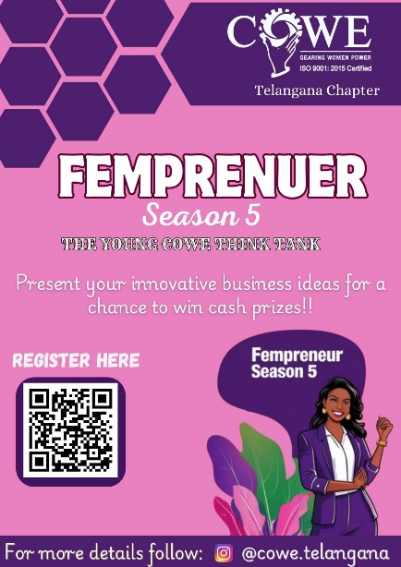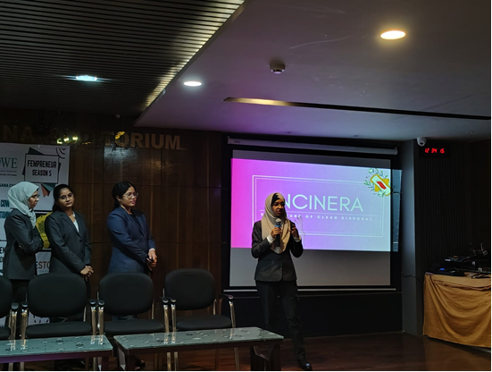

Pitching Day – Explore the Unexplored

The Department of Business Management organized a session titled “Pitching Day – Explore the Unexplored” on 25th April, 2025, exclusively for I MBA students. The session witnessed active participation from 73 students who showcased a range of creative and out-of-the-box business ideas.
Each team pitched their concept, which was followed by an engaging Q&A session. The session offered students immediate and constructive feedback, insights into the practical feasibility of their ideas, and valuable suggestions for refinement. It also served as an excellent platform to enhance their critical thinking, and entrepreneurial capabilities.
The session provided a meaningful experiential learning opportunity, encouraging participants to move beyond conventional thinking and lay the groundwork for future ventures. It was a commendable start to their professional development in the field of business and management.

Intellectual Property Day 2025
On the occasion of World Intellectual Property Day 2025, the Institution's Innovation Council (IIC) and the Research Committee (IPR Cell) jointly organized an expert talk by Dr. V. Samunnatha, Placement Officer and Vice-Principal.
The session aimed to raise awareness among postgraduate students about the importance of Intellectual Property Rights (IPR) in today’s innovation-driven economy. Dr. Samunnatha highlighted the role of IPR in business strategy, legal frameworks, and the protection of creative and intellectual assets. The event successfully enlightened students on how IPR influences entrepreneurship and innovation, and encouraged them to explore the legal and commercial dimensions of intellectual property. With enthusiastic participation 111 postgraduate students and faculty members, the session proved to be highly informative and impactful, fostering a greater understanding of IPR and its significance in creative domains.

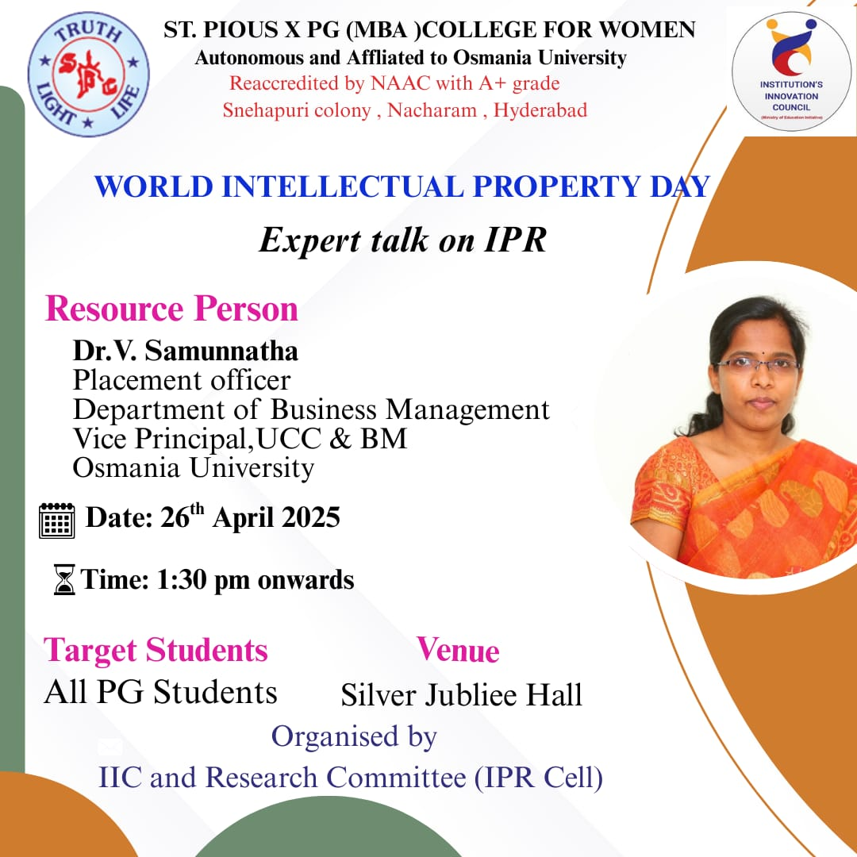

YUKTI:
St. Pious X Degree &amp; PG College for Women is maintaining a Repository of innovations
(NIR)-YUKTI, an initiative of the Ministry of Education (MoE) Government of India for
continuous identification and evaluation of Innovations and start-ups developed by the
Faculty Members, Students and Alumni of the Institution.
As of now a total of 13 registrations,8 ideas submission, 5 assigned and 8 are verified to
the repository. There are a number of ideas developed in the institution which are still in
process of registration and evaluation. Yukti, initiative has developed a culture of
Innovation and offering required assistance for the same.

Visit to Bio- Incubation Center-
Department of Botany & Biotechnology in collaboration with Institution Innovation Council on 18 December 2024, visited the ATAL Bio incubation Centre, CCMB, Hyderabad which is a one of India's Premier Biotechnology incubation centre. It supports the development of innovation start-ups, particularly those working in areas of health, agriculture, and environmental sustainability. Students
Empathised with operational aspects of the ATAL Bio-Incubation Centre (ABIC). Gained insight into the support and services offered to start-ups. Explored opportunities for collaboration and innovation in Biotechnology.

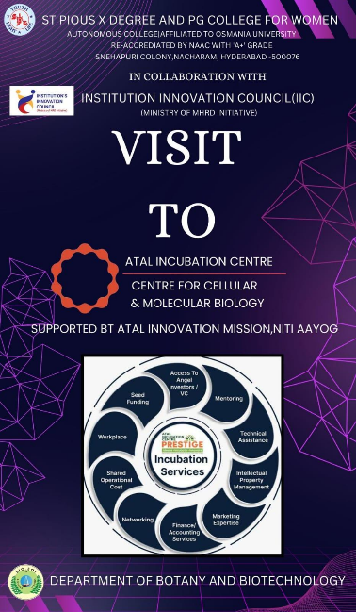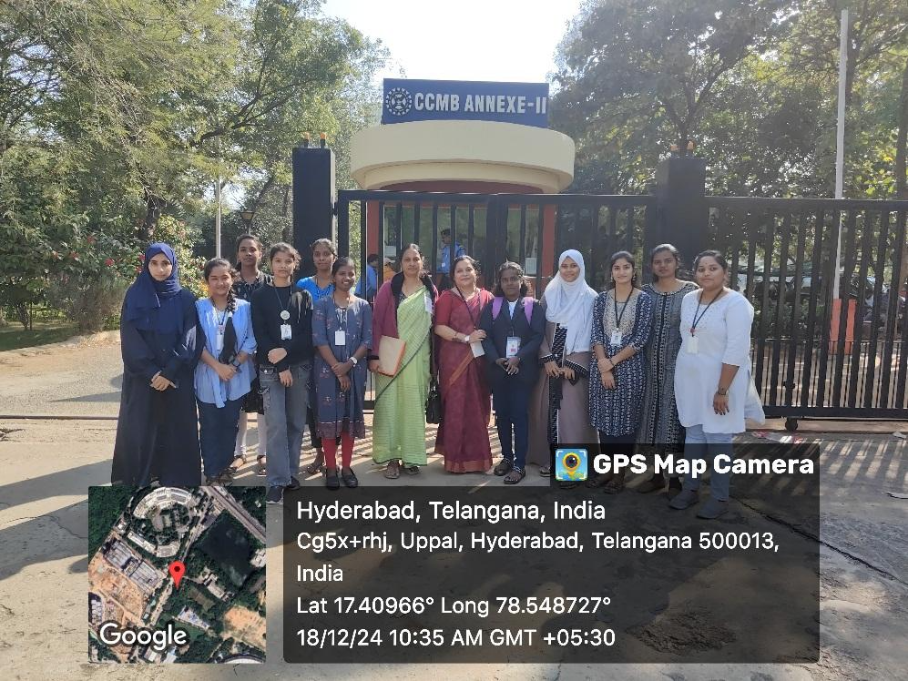

- Highlight selected best Innovations & images with mention of inventor/innovation name
Green Hackathon and Yukti best ideas

- Highlight selected start-ups established by students/faculties with mention of founder/cofounder name - NIL

- List if any break through Innovations / Technology Developed at the institute (2-3 technology with 2-3 lines about technology and innovation

Continuing the internal ideathons / Hackathons/ GREENOTHON that interested students are brainstorming and bringing out new innovative and creative ideas that might be turned into an actual product.

- Participation of IIC-institute in various programs of Central and Stage Govt. Highlighting specially for the schemes or programs.

NISP Adoption status - Trained Faculty, Policy Formulation, Policy Implementation
Mrs.P. Harshanya Asst. Professor, Dept. of Business Management, St. Pious X MBA College for Women had participated in the first training session of NISP.

Report as Participating Institute:
- 15 teams from our institute had sent the ideas for Hackathon SIH – 2024.
- YUKTI challenge 2024, total 13 ideas registered, total submitted ideas 7, assigned 5 and 7 are verified.

Benefits: Inculcated team spirit amongst students and sensitized students towards design Thinking.

- Detail of social media & Connections of IIC institute
- Instagram Account: https://www.instagram.com/stpiouscollege/?hl=enw
- Facebook: https://www.facebook.com/StpiousX
- Twitter: https://twitter.com/pious_x
- Website: http://www.stpiouscollege.org

- Testimonials from IIC members and external about IIC institute and IIC of MoE’s Innovation Cell

Mrs. Jacquline
Social Media Coordinator, IIC of St.Pious X Degree and PG College for Women, Hyderabad, Telangana
I thank MoE for giving opportunity to higher educational institutions to Start IIC and guiding us in many activities which instill creative thinking among students. We are glad to be a part of Cyber Hackathon “KAVACH-2023”.

Dr. P. Suhasini Associate Professor
Being a part of Innovation Ambassador Training I would like to thank Ministry of Education Institute Innovation Council for their efforts in guiding faculty of Higher Educational Institutes and made us understand the importance of the role of faculty in mentoring the students and equipping us with knowledge on topics like IPR Design Thinking and Entrepreneurship.

Dr. Snehalatha
Convenor, IIC St. Pious X Degree & PG College for Women ,
I take this opportunity to thank MoE Innovation council and I truly appreciate MIC and IIC of the college for making me a part of the Innovation Cell. This has helped the faculty and students of the higher Education institutions what innovation has to offer in different fields. Being a social media coordinator it was a fantastic opportunity to share the best practices and learn about new channels and enhancement of the channels and network with other channel professionals.

4. Hirshita Biswil I BBA
Student, St. Pious X Degree & PG College for Women

The IIC council at ST. PIOUS X DEGREE AND PG COLLEGE has given us members a very great opportunity to experience the advance learning and expose our talent to the top most platform. There has been various programmes conducted which helped us to think out of the content and explore the world of creativity on a next level. The Toycathon program conducted by the IIC MIC was the best platform where me and my team had a unique way of learning by experience. Our overall journey in the program was a sterling one. We open to the competition where we got the vast chance of learning something which we wouldn’t get anywhere else.

Miss Sravani, Second B.Com Business Analytics
Student, St. Pious X Degree & PG College for Women
Creativity is thinking up new things, innovation is doing new things. I have sharpened my creativity and innovation capabilities at St. Pious X DEGREE AND PG COLLEGE for women. Dr.R. Komala ma'am, member IIC at St. Pious X Degree and PG college for women, has helped me gain the confidence and present my idea in the Fempreneur 2023 competition and I bagged 1st prize. This competition took me through a new road of learning and exploring.
The IIC is always conducting sessions and webinars for us to improve and I have personally gained much knowledge from the sessions I attended. I am very grateful for everything I received here.

- Images

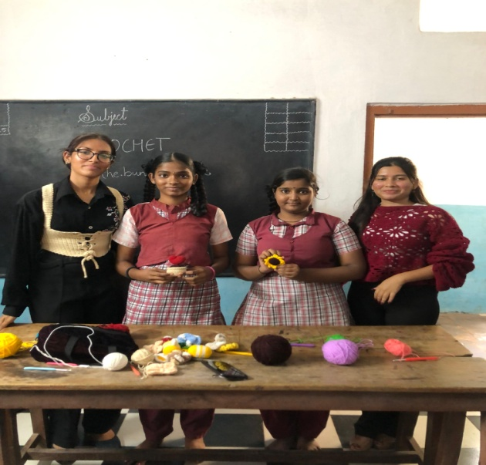

N Contact

Head of the Institution
Sr. Dr. B. Velangini Kumari principalstpiouscollege@gmail.com principal@stpiouscollege.org 9849725030
7396942708

************

